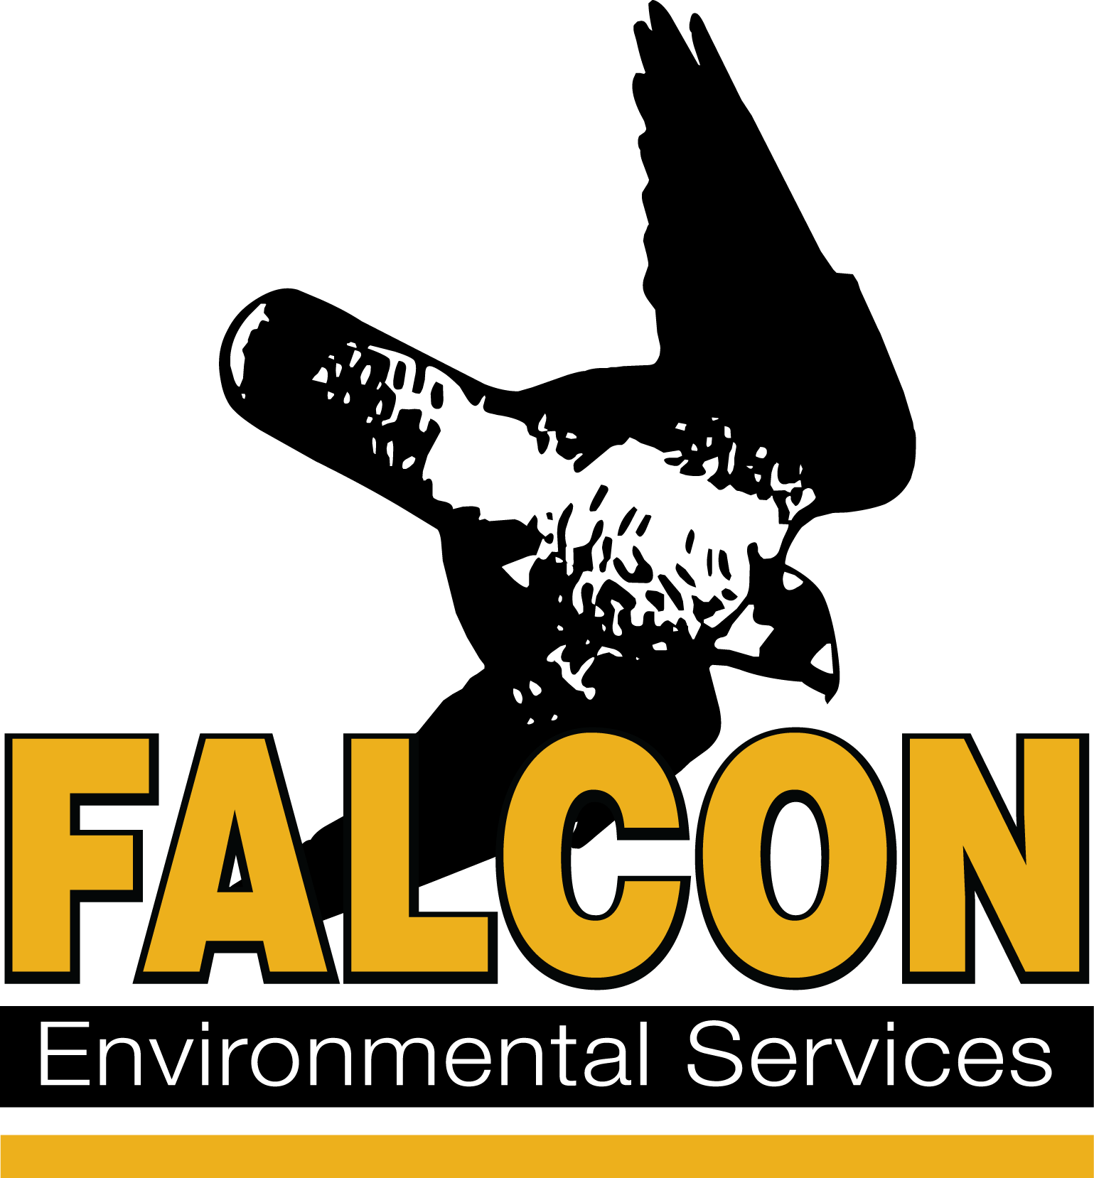
Falcon Environmental Services, Inc.

Training Register Form

Training Date:
Training Location:
Personal Information
Last Name:
First Name:
Occupation:
Organization:
Address:
Email:
Phone Number:

Method of Payment
The cost of the 1-day training is $ 250 per person. Please add applicable taxes.
The cost of the 2-days training is $ 450 per person. Please add applicable taxes.
Please send me an invoice.
Check. Please make payable to Falcon Environmental Services, Inc. and bring it the day of the training.
Credit Card: Visa MasterCard American Express
Credit Card Holder:
Card Number:
Expiration (MM/YY): /
Travel expenses will apply if the training is given outside our premises.

Please return the completed form to training@falconenvironmental.com.
www.falconenvironmental.com | training@falconenvironmental.com | 450-458-1333 LEADERS IN THE FIELDTM since 1989

