Personal Information
Name and Surname:
Organization:
Billing Address: .
Shipping Address (if different):
Phone: .
Email:

Instructions
- Enter the total number desired for each item.
- Right click on the field of the Total column for each added item and click Update fields
- Shipping fees and applicable taxes will be added.

Order
Items |  | Reference | Cost |  | Quantity | Total
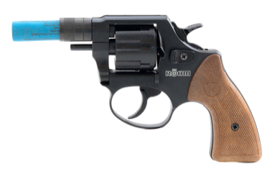 | RG-46 Seven Shot Revolver Launcher | 5400 | $ | 185,00 |  | $ 0,00
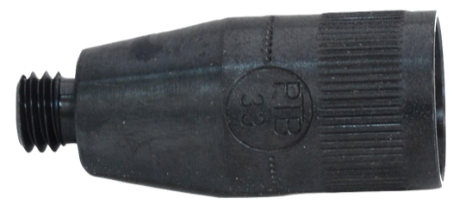 | RG-46 Spare Muzzle Cup | 5406 | $ | 10,50 |  | $ 0,00
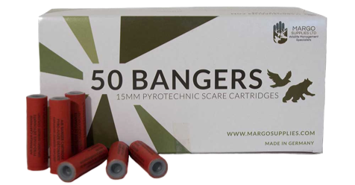 | Bangers  (Box of 50) | 6000 | $ | 27,75 |  | $ 0,00
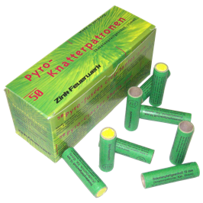 | Screamers  (Box of 50) | 6001 | $ | 27,75 |  | $ 0,00
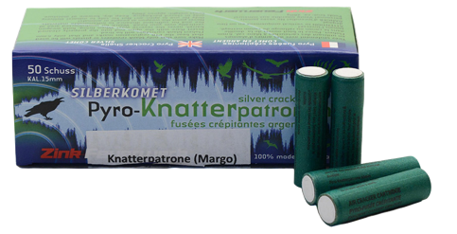 | Screamers with Silver Comet  (Box of 50) | 6006 | $ | 29,90 |  | $ 0,00
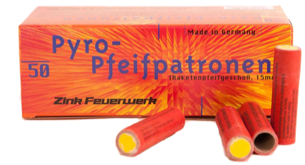 | Flaming Whistlers  (Box of 50) | 6003 | $ | 27,75 |  | $ 0,00
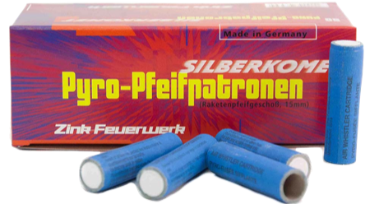 | Whistler with Silver Comet  (Box of 50) | 6002 | $ | 29,90 |  | $ 0,00
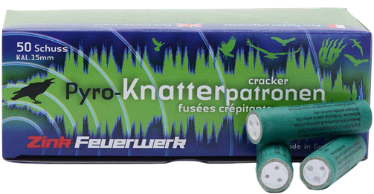 | Screamer Booster  (Box of 50) | 6007 | $ | 27,75 |  | $ 0,00
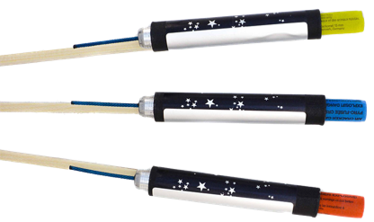 | XTR Extended Range Rocket  (one unit) | 6008 | $ | 7,35 |  | $ 0,00
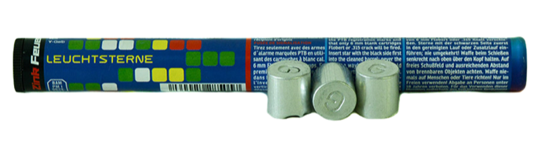 | Color Flares  (Box of 10) | 6004 | $ | 9,00 |  | $ 0,00
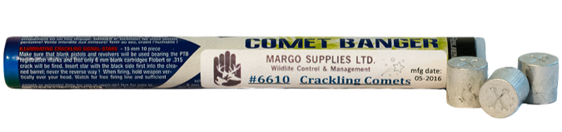 | Crakling Comet/Comet Banger  (Box of 10) | 6010 | $ | 10,50 |  | $ 0,00
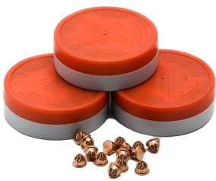 | 6 mm Blanks  (Box of 100) | 6050 | $ | 8,75 |  | $ 0,00
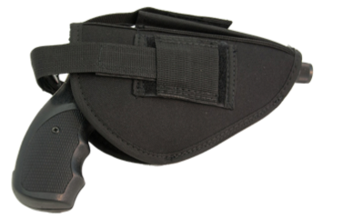 | Launcher Holster | 5098a | $ | 12,50 |  | $ 0,00
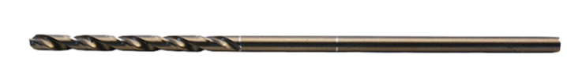 | 3/16’’ Aviation Bit | 5705 | $ | 12,00 |  | $ 0,00
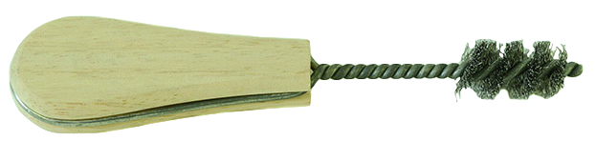 | Wire Muzzle Brush | 5703 | $ | 7,60 |  | $ 0,00
 | Nylon Magazine Chamber Brush | 5704 | $ | 6,30 |  | $ 0,00
 | Dual Headed Bronze Brush | 5706 | $ | 6,75 |  | $ 0,00
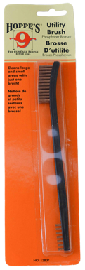 | Bore/Port Brush | 5702 | $ | 6,75 |  | $ 0,00
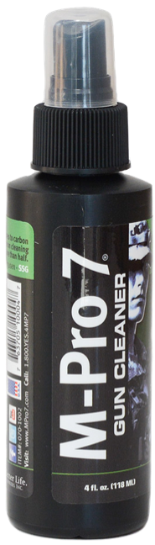 | Launcher Cleaning Solution  (4 oz) | 5700a | $ | 28,50 |  | $ 0,00
 | Launcher Cleaning Solution  (8 oz) | 5700b | $ | 45,00 |  | $ 0,00
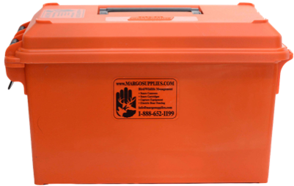 | Drybox | 6065 | $ | 22,70 |  | $ 0,00
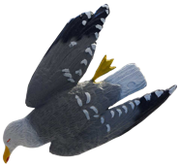 | Dead Seagull Decoy | 1938 | $ | 31,25 |  | $ 0,00
 | Paint Ball Marker | 5900 | $ | 250,00 |  | $ 0,00
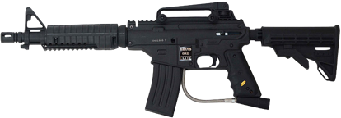 | Tippman Bravo One Elite Paintball Marker | 5908 | $ | 225,00 |  | $ 0,00
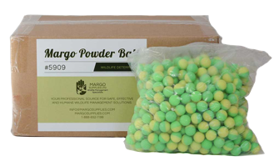 | Powder Ball .68 Cal  (Box of 2,000) | 5909 | $ | 139,95 |  | $ 0,00
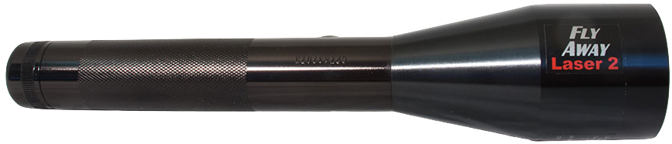 | Bird Scare Laser Adjustable Beam | 1902 | $ | 900,00 |  | $ 0,00
 |  |  |  |  | TOTAL | 0,00 $*
* Delivery charges and applicable taxes will be added.

